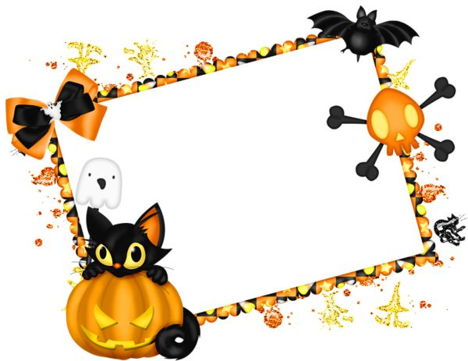

We hope you have a great Halloween

But PLEASE DON’T DISTURB OUR LITTLE MONSTER TONIGHT

NO TRICK OR TREATERS PLEASE!

**Shhhhhh Baby Sleeping!**